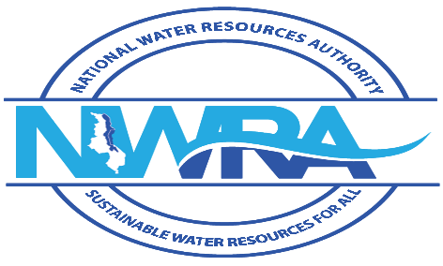

WATER RESOURCES ACT

(Cap.72:03)

WATER RESOURCES REGULATIONS, 2018

**FORM B2**

APPLICATION FOR PERMISSION TO REHABILITATE DEFECTIVE BOREHOLES

*To be filled in triplicate*

**1. Names and addresses of client**

|  |  |
| --- | --- |
| Name |  |
| Address |  |
| District |  |
| Telephone |  |
| Mobile Phone |  |
| Email |  |

**2. Details of the borehole**

Licence number of the borehole: ___________________________________________________________

Location of the borehole (Coordinates Village/Area, Traditional Authority, Water Resources Area, and District): _____________________________________________________________________________________

Borehole depth (m): ___________________________________________________________________

Casing diameter (mm): _________________________________________________________________

Static water level (m): __________________________________________________________________

Amount and location of casing or sealing in the borehole: ______________________________________

Details of the strata

|  |  |
| --- | --- |
| **Depth (interval)** | **Description of the Strata (include issues of water quality if any)** |
|  |  |
|  |  |
|  |  |
|  |  |

3. **Rehabilitation details**

Describe the methods of rehabilitation of the borehole

_______________________________________________________________________________________________________________________________________________________________________________________________________________________________________________________________

**Declaration of the Applicant**

I certify that the information provided in this form is correct to the best of my knowledge. I also agree that no decision will be made pursuant to this application until I receive a notification from the Authority of water development that I have provided all the necessary information.

Signature of Applicant**: ________________________________________________________________**

Full names _________________________________________________ Date ____________________

Note: When you have completed this form and the appropriate attachments, you must attach a copy of bank cash deposit slip or cheque for _________ Kwacha for processing the application and sent them to:

The Executive Director, National Water Resources Authority, Private Bag 363, Lilongwe 3, Telephone: +265 (0) 111 647 907 , Email: nwrasec@gmail.com

The Authority may require you to advertise this application at your cost in a way specified by the Authority. Attach a copy of the borehole completion report.

**For Official Use Only**

Date of receipt of the application: _______________________________________________________

Application number: _________________________________________________________________

Borehole No: _______________________________________________________________________

WRA No.: _________________________________________________________________________

Name of the officer receiving the application: ______________________________________________

Designation: _______________________________________________________________________

Signature: _________________________________________________________________________

Official stamp: _____________________________________________________________________