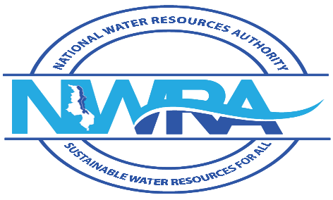

WATER RESOURCES ACT

(reg.106(2))

(Cap.72:03)
WATER RESOURCES REGULATIONS, 2018 FORM M

APPLICATIONS FOR EXEMPTION OF INFORMATION FROM THE PUBLIC REGISTER

This form should be used to apply to the Authority for the exclusion of commercially sensitive information from the public registers on waste discharges.

The completed application form should be submitted to the Authority with the application form for a permit to discharge.

Please complete the relevant sections of this form IN BLOCK LETTERS, attach it to your application for a permit to discharge and return both forms to the Authority.

I/We* request the Authority, under the provisions of these Regulations, to exclude commercially sensitive information from the public register on waste discharges. The information for exclusion and the reasons for exclusion are described below or on the listed attachments.

Signature of Applicant: ____________________________________ Date _______________________
Signed on behalf of ___________________________________________________________________

1. Name and address of applicant (or agent for company)—
Full Names: __________________________________________________________________________
Address: ___________________________________________________________________________
Telephone: _______________ Fax: _________________ Email: _______________________________

Acting for (company /partnership/public corporation/cooperative society)*
Address: ____________________________________________________________________________
Address for correspondence if different from above: __________________________________________

2. Commercially sensitive information for exclusion from the register (Please identify specifically the information, included in the application form for a permit to discharge, which you wish to be excluded from the public register).
______________________________________________________________________________________

3. Reasons for exclusion of information from the register (Please provide clear justification for each item of information you wish to be excluded from the public register. (Note - The onus is on the applicant to justify the exclusion of information. If the Authority is not satisfied that your application is justified he will reject your application.)
__________________________________________________________________________________________________________________________________________________________________________________________________________________________________________________________________

- Attachments (Please attach all information, relevant to this application, to this form and list the attachments in the space provided) - (List any attachments to this form in the space below.)
____________________________________________________________________________________
___________________________________________________________________________________
___________________________________________________________________________________

I/We* certify that the information provided in this form is complete and correct to the best of my/our* knowledge.
Date: ___________________________________ Signature: __________________________________

Official Stamp: ________________________________________________________________________

When you have completed this form, you should return and you must attach a copy of bank cash deposit slip or cheque for _________ Malawi Kwacha for processing the application and send it to
The Executive Director, National Water Resources Authority, Private Bag 363, Lilongwe 3, Telephone: +265 (0) 111 647 907 , Email: nwrasec@gmail.com
, together with any attachments as indicated above.

The Authority may require further information, to discuss the exemptions with you, before making a determination as to whether the proposed exemptions are justified.

Official Use Only

Exemption No.: ______________________________________________________________________

Date received:_______________________________________________________________________

