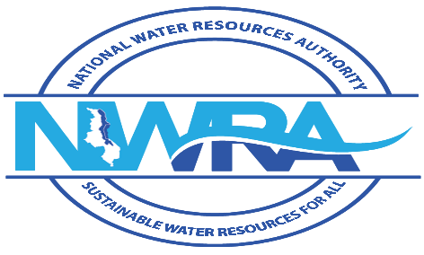

WATER RESOURCES ACT

(reg.94(1))

WATER RESOURCES REGULATIONS, 2018 **FORM K**

NOTIFICATION OF TRANSFER OF PERMIT TO DISCHARGE EFFLUENT

This form should be used to register the transfer of a permit to discharge for an existing discharge to the new owner of the operation to which it applies. If the operation is to change in any way a new permit to discharge must be obtained before the changes can be implemented.

Please complete the relevant sections of this form in triplicate IN BLOCK LETTERS and return it to the Authority within twenty-one days of the transfer.

I/We* notify the authority that the permit to discharge, Reference No. ______ was transferred to new holder on ___________________________________

Signature of new holder: ____________________________________ Date ______________________

Signed on behalf of ___________________________________________________________________

**1. Name and address of new holder (or agent for company)—**

Full Names: __________________________________________________________________________

Address: ___________________________________________________________________________

Address for correspondence (if different from above): ________________________________________

Telephone: _______________ Fax: _________________ Email: _______________________________

**2. Reasons for transfer—**

Please give your reasons for transferring this permit to other persons or company.

_______________________________________________________________________________________________________________________________________________

**Note—**

It is an offence under these Regulations to fail to register the transfer of this permit within twenty-one days of the transfer taking place. If you fail to do so you may be subject to a fine or a custodial sentence.

I/We* certify that the information provided in this form is complete and correct to the best of my/our* knowledge.

Date: ____________________ Signature: _______________________________________________

When you have completed this form, you should return and you must attach a copy of bank cash deposit slip or cheque for _________ Malawi Kwacha for processing the application and send it to

the Executive Director, National Water Resources Authority, Private Bag 363, Lilongwe 3, Telephone: +265 (0) 111 647 907 , Email: nwrasec@gmail.com

together with any attachments indicated above.

The Authority may require further information to discuss the transfer with you, before making a determination as to whether the proposed transfer is acceptable.

**Official Use Only**

Application No.: ________________________________________________________________________

Date received: _______________________________________________________________________

This transfer has been authorized/not authorized.

Name: ____________________________________ Signature: ___________________________________

Official Stamp:_________________________________________________________________________

The Executive Director, National Water Resources Authority, Private Bag 363, Lilongwe 3, Telephone: +265 (0) 111 647 907 , Email: nwrasec@gmail.com